OPT 328 GENERAL PHARMACOLOGY 2020/2021

DR OKORO CHIEMELA C.

LECTURE 2

Dose-Response Relationships
Regardless of how a drug effect occurs—through binding or chemical interaction—the concentration of the drug at the site of action controls the effect. However, response to concentration may be complex and is often nonlinear. The relationship between the drug dose, regardless of route used, and the drug concentration at the cellular level is even more complex.

Agonist drugs mimic the action of the endogenous ligand for the receptor (for example, isoproterenol mimics norepinephrine on β1 receptors of the heart). The magnitude of the drug effect depends on receptor sensitivity to the drug and the drug concentration at the receptor site, which, in turn, is determined by both the dose of drug administered and by the drug’s pharmacokinetic profile, such as rate of absorption, distribution, metabolism, and elimination.
Graded dose–response relationship
As the concentration of a drug increases, its pharmacologic effect also gradually increases until all the receptors are occupied (the maximum effect). Plotting the magnitude of response against increasing doses of a drug produces a graded dose–response curve that has the general shape depicted in Figure below. Two important drug characteristics, potency and efficacy, can be determined by graded dose–response curves.
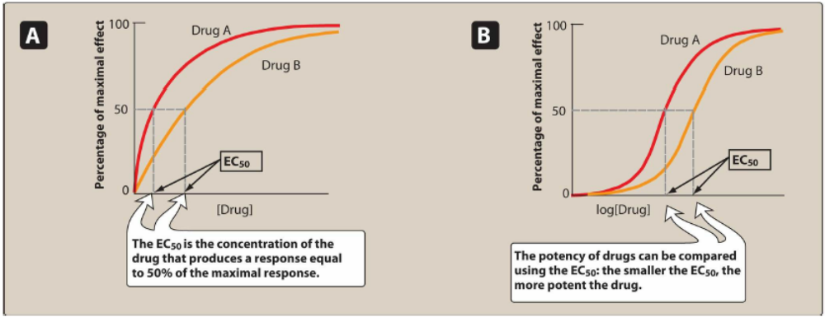
Fig. 1. The effect of dose on the magnitude of pharmacologic response. Panel A is a linear plot. Panel B is a semilogarithmic plot of the same data. EC50 = drug dose causing 50% of maximal response.

Potency
Potency is a measure of the amount of drug necessary to produce an effect. The concentration of drug producing 50% of the maximum effect (EC50) is often used to determine potency. In Figure 1, the EC50 for Drugs A and B indicate that Drug A is more potent than Drug B, because a lesser amount of Drug A is needed to obtain 50% effect. Therapeutic preparations of drugs reflect their potency. For example, candesartan and irbesartan are angiotensin receptor blockers used to treat hypertension. The therapeutic dose range for candesartan is 4 to 32 mg, as compared to 75 to 300 mg for irbesartan. Therefore, candesartan is more potent than irbesartan (it has a lower EC50 value).
Since the range of drug concentrations that cause from 1% to 99% of maximal response usually spans several orders of magnitude, semilogarithmic plots are used to graph the complete range of doses. As shown in Figure 1B, the curves become sigmoidal in shape, which simplifies the interpretation of the dose–response curve.

STUDY QUESTION: If 1 mg of lorazepam produces the same anxiolytic response as 10 mg of diazepam, what is correct?
ANS: A drug that causes the same effect at a lower dose is more potent.

Efficacy
Efficacy is the magnitude of response a drug causes when it interacts with a receptor. Efficacy is dependent on the number of drug–receptor complexes formed and the intrinsic activity of the drug (its ability to activate the receptor and cause a cellular response). Maximal efficacy of a drug (Emax) assumes that the drug occupies all receptors, and no increase in response is observed in response to higher concentrations of drug. The maximal response differs between full and partial agonists, even when the drug occupies 100% of the receptors. Similarly, even though an antagonist occupies 100% of the receptor sites, no receptor activation results and Emax is zero. Efficacy is a more clinically useful characteristic than potency, since a drug with greater efficacy is more therapeutically beneficial than one that is more potent. Figure 2. shows the response to drugs of differing potency and efficacy.
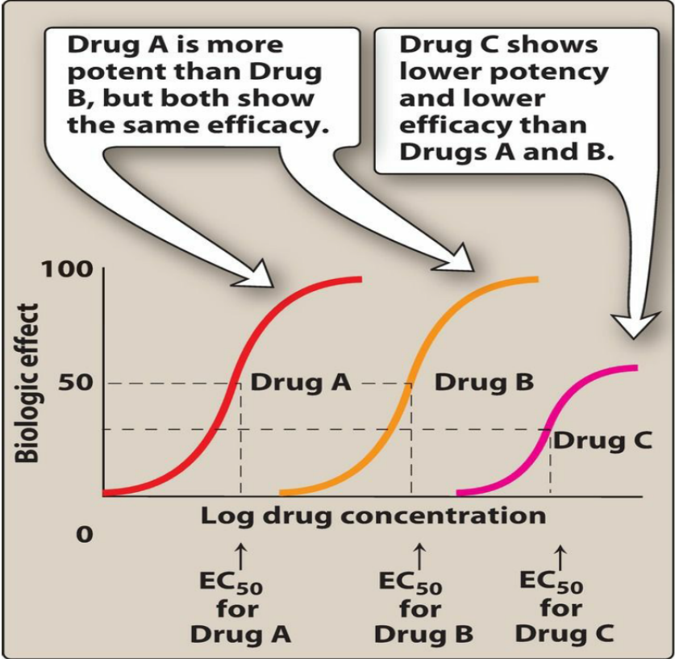
Figure 2. Typical dose–response curve for drugs showing differences in potency and efficacy. EC50 = drug dose that shows 50% of maximal response.

Effect of drug concentration on receptor binding
The quantitative relationship between drug concentration and receptor occupancy applies the law of mass action to the kinetics of the binding of drug and receptor molecules:
By making the assumption that the binding of one drug molecule does not alter the binding of subsequent molecules and applying the law of mass action, we can mathematically express the relationship between the percentage (or fraction) of bound receptors and the drug concentration:
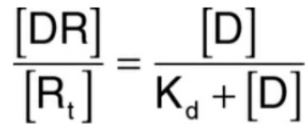

where [D] = the concentration of free drug, [DR] = the concentration of bound drug, [Rt] = the total number of
receptors, and Kd = the equilibrium dissociation constant for the drug from the receptor. The value of Kd can be used to determine the affinity of a drug for its receptor. Affinity describes the strength of the interaction (binding) between a ligand and its receptor. The higher the Kd value, the weaker the interaction and the lower the affinity, and vice versa. Equation (1) defines a curve that has the shapes shown in Figure 3 when plotted against drug concentration (Panel A) or log drug concentration (Panel B). As the concentration of free drug increases, the ratio of the concentrations of bound receptors to total receptors approaches unity, thereby producing the maximal effect.
Thus, it is not surprising that the curves shown in Figure 3 and those representing the relationship between dose and effect (Figure 1) are similar.
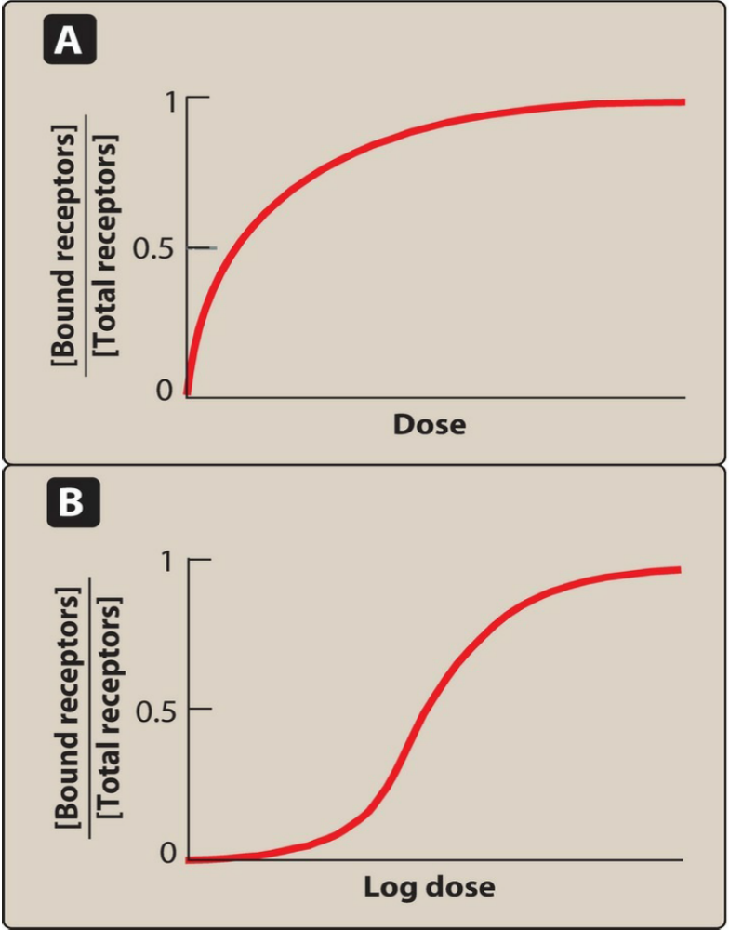
Figure 3. The effect of dose on the magnitude of drug binding.

Relationship of drug binding to pharmacologic effect
The law of mass action can be applied to drug concentration and response providing the following assumptions are met: 1) The magnitude of the response is proportional to the amount of receptors occupied by drug, 2) the Emax occurs when all receptors are bound, and 3) one molecule of drug binds to only one molecule of receptor. In this case,
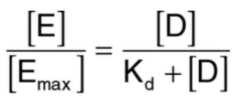

Where [E] = the effect of the drug at concentration [D] and [Emax] = the maximal effect of the drug.
Thus, it follows that if a specific population of receptors is vital for mediating a physiological effect, the affinity of an agonist for binding to those receptors should be related to the potency of that drug for causing that physiological effect. Many drugs and most neurotransmitters can bind to more than one type of receptor, thereby causing both desired therapeutic effects and undesired adverse effects. In order to establish a relationship between drug occupation of a particular receptor subtype and the corresponding biological response to that drug, correlation curves of receptor affinity and drug potency are often constructed.

Intrinsic Activity
As mentioned before, an agonist binds to a receptor and produces a biologic response based on the concentration of the agonist, its affinity for the receptor and, hence, the fraction of occupied receptors. However, the intrinsic activity of a drug further determines its ability to fully or partially activate the receptors. Drugs may be categorized according to their intrinsic activity and resulting Emax values.
Full agonists
If a drug binds to a receptor and produces a maximal biologic response that mimics the response to the endogenous ligand, it is a full agonist (Figure 4). Full agonists bind to a receptor, stabilizing the receptor in its active state and are said to have an intrinsic activity of one. All full agonists for a receptor population should produce the same Emax.
For example, phenylephrine is a full agonist at α1-adrenoceptors, because it produces the same Emax as the
endogenous ligand, norepinephrine. Upon binding to α1-adrenoceptors on vascular smooth muscle, both
norepinephrine and phenylephrine stabilize the receptor in its active state, thereby increasing Gq activation.
Activation of Gq increases intracellular Ca2+, causing interaction of actin and myosin filaments and shortening of the muscle cells. The diameter of the arteriole decreases, causing an increase in resistance to blood flow through the vessel and an increase in blood pressure. Thus, effects of agonists on intracellular molecules, cells, tissues, and intact organisms are all attributable to interaction of the drug with the receptor. For full agonists, the dose–response curves for receptor binding and each of the biological responses should be comparable.
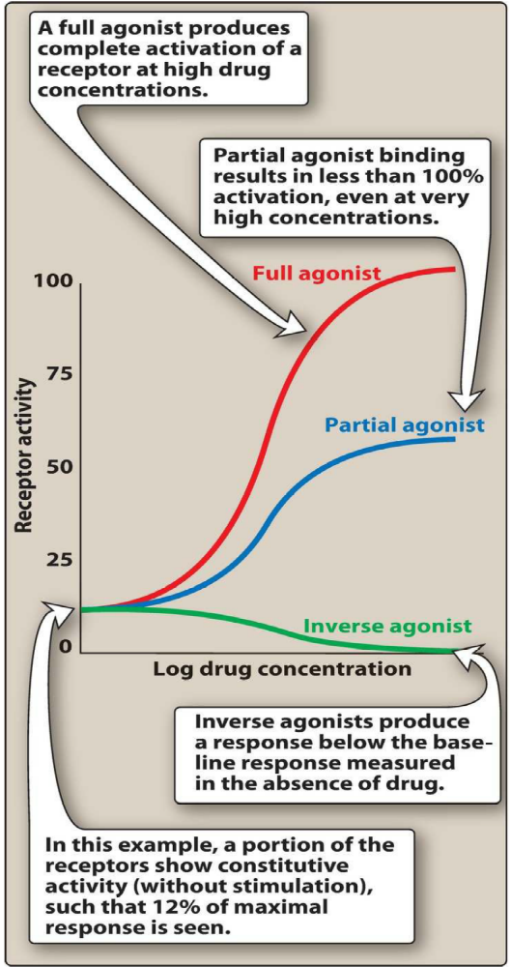
Figure 4. Effects of full agonists, partial agonists, and inverse agonists on receptor activity.

Partial agonists
Partial agonists have intrinsic activities greater than zero but less than one (Figure 4). Even when all the receptors are occupied, partial agonists cannot produce the same Emax as a full agonist. Even so, a partial agonist may have an affinity that is greater than, less than, or equivalent to that of a full agonist. A partial agonist may also act as a partial antagonist of a full agonist (Figure 5). As the number of receptors occupied by the partial agonist increases, the number of receptors that can be occupied by the full agonist decreases and therefore Emax would decrease until it reached the Emax of the partial agonist. This potential of partial agonists to act as both an agonist and antagonist may have therapeutic utility. For example, aripiprazole, an atypical antipsychotic, is a partial agonist at selected dopamine receptors. Overactive dopaminergic pathways tend to be inhibited by aripiprazole, whereas underactive pathways are stimulated. This might explain the ability of aripiprazole to improve symptoms of schizophrenia, with a small risk of causing extrapyramidal adverse effects.
Inverse agonists
Typically, unbound receptors are inactive and require interaction with an agonist to assume an active conformation.
However, some receptors show a spontaneous conversion from R to R* in the absence of an agonist. Inverse
agonists, unlike full agonists, stabilize the inactive R form and cause R* to convert to R. This decreases the number of activated receptors to below that observed in the absence of drug (Figure 4). Thus, inverse agonists have an intrinsic activity less than zero, reverse the activation state of receptors, and exert the opposite pharmacological effect of agonists.
Antagonists
Antagonists bind to a receptor with high affinity but possess zero intrinsic activity. An antagonist has no effect on biological function in the absence of an agonist, but can decrease the effect of an agonist when present. Antagonism may occur either by blocking the drug’s ability to bind to the receptor or by blocking its ability to activate the receptor.
1. Competitive antagonists
If the antagonist binds to the same site on the receptor as the agonist in a reversible manner, it is “competitive.” A competitive antagonist interferes with an agonist binding to its receptor and maintains the receptor in its inactive state. For example, the antihypertensive drug terazosin competes with the endogenous ligand norepinephrine at α1- adrenoceptors, thus decreasing vascular smooth muscle tone and reducing blood pressure. However, increasing the concentration of agonist relative to antagonist can overcome this inhibition. Thus, competitive antagonists characteristically shift the agonist dose–response curve to the right (increased EC50) without affecting Emax.
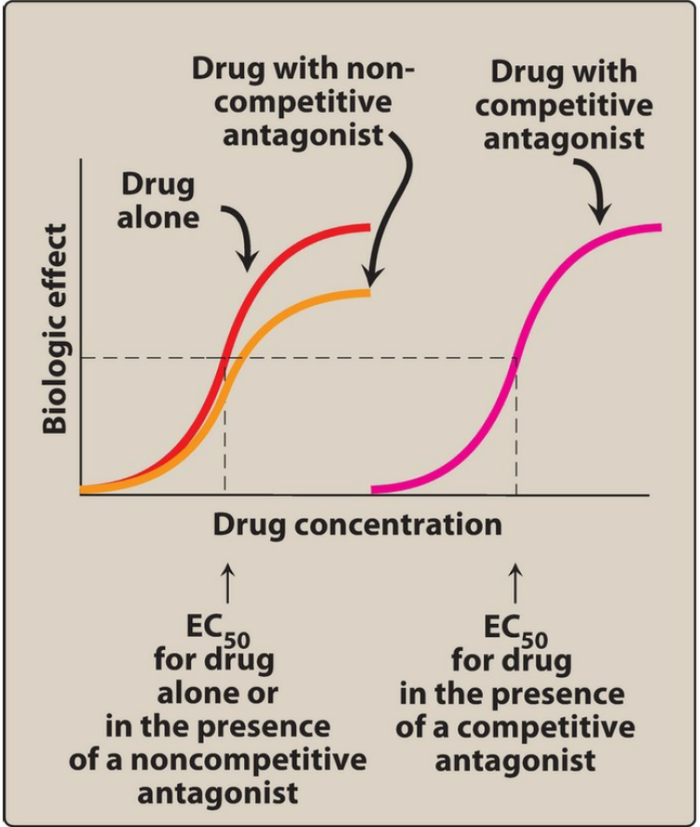
Figure 5. Effects of drug antagonists. EC50 = drug dose that shows 50% of maximal response.

Irreversible antagonists
Irreversible antagonists bind covalently to the active site of the receptor, thereby permanently reducing the number of receptors available to the agonist. An irreversible antagonist causes a downward shift of the Emax, with no shift of EC50 values (Figure 5). In contrast to competitive antagonists, addition of more agonist does not overcome the effect of irreversible antagonists. Thus, irreversible antagonists and allosteric antagonists (see below) are both considered noncompetitive antagonists. A fundamental difference between competitive and noncompetitive antagonists is that competitive antagonists reduce agonist potency (increase EC50) and noncompetitive antagonists reduce agonist efficacy (decrease Emax).
Allosteric antagonists
An allosteric antagonist binds to a site (allosteric site) other than the agonist-binding site and prevents receptor activation by the agonist. This type of antagonist also causes a downward shift of the Emax of an agonist, with no change in the EC50 value. An example of an allosteric agonist is picrotoxin, which binds to the inside of the GABA-controlled chloride channel. When picrotoxin binds inside the channel, no chloride can pass through the channel, even when GABA fully occupies the receptor.

Functional antagonism
Functional antagonism is a term used to represent the interaction of two agonists that act independently of each other but happen to cause opposite effects. Thus, indirectly, each tends to cancel out or reduce the effect of the other. A classic example is the functional antagonism by epinephrine to histamine-induced bronchoconstriction.
Histamine binds to H1 histamine receptors on bronchial smooth muscle, causing bronchoconstriction of the
bronchial tree. Epinephrine is an agonist at β2-adrenoceptors on bronchial smooth muscle, which causes the muscles to relax. This functional antagonism is also known as “physiologic antagonism.”
Quantal Dose–Response Relationships
Another important dose–response relationship is that between the dose of the drug and the proportion of a population of patients that responds to it. These responses are known as quantal responses, because, for any individual, either the effect occurs or it does not. Graded responses can be transformed to quantal responses by designating a predetermined level of the graded response as the point at which a response occurs or not. For example, a quantal dose–response relationship can be determined in a population for the antihypertensive drug atenolol. A positive response is defined as a fall of at least 5 mm Hg in diastolic blood pressure. Quantal dose– response curves are useful for determining doses to which most of the population responds. They have similar shapes as log dose–response curves, and the ED50 is the drug dose that causes a therapeutic response in half of the population.
Therapeutic index
The therapeutic index (TI) of a drug is the ratio of the dose that produces toxicity in half the population (TD50) to the dose that produces a clinically desired or effective response (ED50) in half the population: 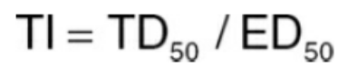
The TI is a measure of a drug’s safety, because a larger value indicates a wide margin between doses that are effective and doses that are toxic.
Clinical usefulness of the therapeutic index
The TI of a drug is determined using drug trials and accumulated clinical experience. These usually reveal a range of effective doses and a different (sometimes overlapping) range of toxic doses. Although high TI values are required for most drugs, some drugs with low therapeutic indices are routinely used to treat serious diseases. In these cases, the risk of experiencing adverse effects is not as great as the risk of leaving the disease untreated. Figure 6 shows the responses to warfarin, an oral anticoagulant with a low TI, and penicillin, an antimicrobial drug with a large TI.
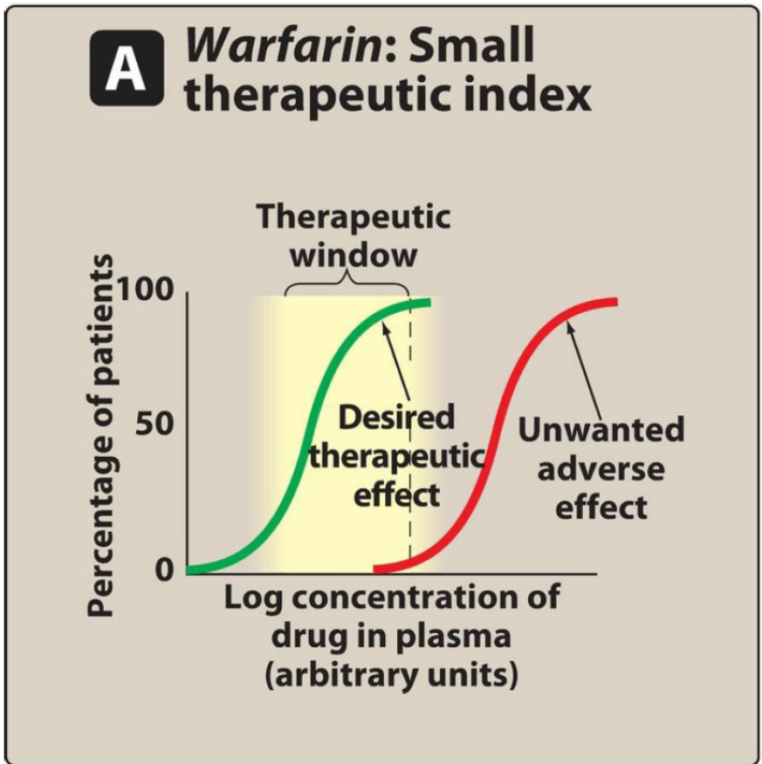
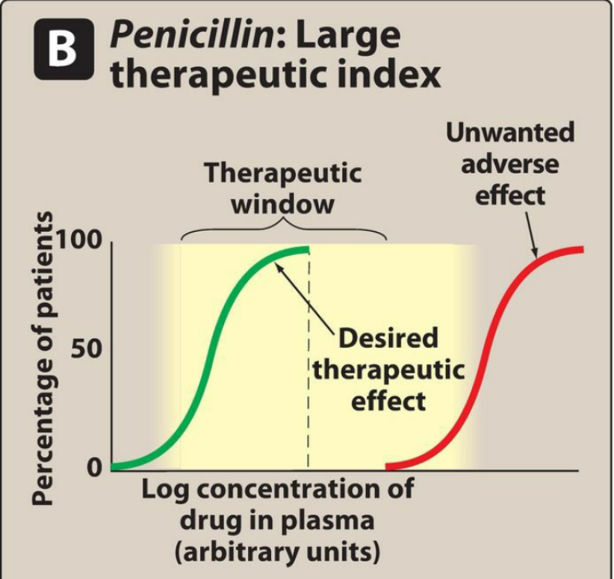
Figure 6. Cumulative percentage of patients responding to plasma levels of warfarin and penicillin.

Warfarin (example of a drug with a small therapeutic index)
As the dose of warfarin is increased, a greater fraction of the patients respond (for this drug, the desired response is a two- to threefold increase in the international normalized ratio [INR]) until, eventually, all patients respond (Figure 6A). However, at higher doses of warfarin, anticoagulation resulting in hemorrhage occurs in a small percent of patients. Agents with a low TI (that is, drugs for which dose is critically important) are those drugs for which bioavailability critically alters the therapeutic effects.
Penicillin (example of a drug with a large therapeutic index)
For drugs such as penicillin (Figure 6B), it is safe and common to give doses in excess of that which is minimally required to achieve a desired response without the risk of adverse effects. In this case, bioavailability does not critically alter the therapeutic or clinical effects.

Protective Index
The margin of safety is only one of several criteria to be used in determining a drug’s clinical merit. Clearly, the therapeutic index is a very rough measure of safety and generally represents only the starting point in determining whether a drug is safe enough for human use. Usually, undesirable side effects occur in doses lower than the lethal doses. For example, phenobarbital induces drowsiness and an associated temporary neurological impairment. Since anticonvulsant drugs are intended to allow people with epilepsy to live normal seizure-free lives, sedation is unacceptable. Thus, an important measure of safety for an anticonvulsant would be the ratio ED50 (neurological impairment)/ED50 (seizure protection). This ratio is called a protective index.
The protective index for phenobarbital is approximately 3. It is easy to see that data derived from dose–response curves can be used in a variety of ways to compare the clinical usefulness of drugs. For instance, a drug with a protective index of 1 is useless as an anticonvulsant, since the dose that protects against convulsion causes an unacceptable degree of drowsiness. A drug with a protective index of 5 would be a more promising anticonvulsant than one with an index of 2.

